**Maiza Falcon Rojas**

**February 16, 2024**

**Assignment: Milestone 3**

**Class: CST-239**

**Github Link:**

**Loom link:**

**Figure 1: UML Diagram**

**Figure 2: Flowchart**

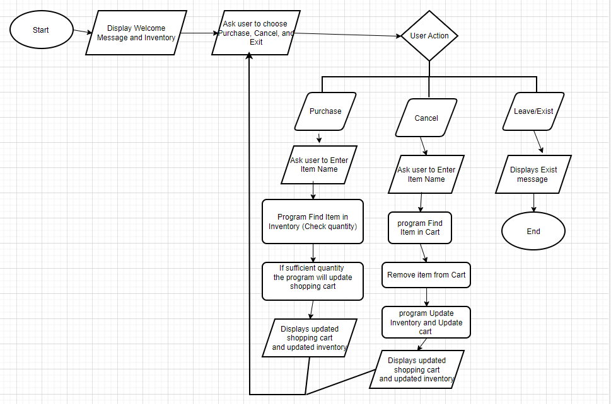

**Follow Up Questions:**

**What was challenging?**

Ensuring that the classes implement the required interfaces and consistently was challenging, especially when dealing with multiple classes.

**What did you learn?**

I learned how to implement interfaces to existing classes while making sure that the code runs properly.

**How would you improve on the project?**

What I would improve is clearer instruction. I honestly was not sure if I should use the code from previous milestones or create a whole new code, so I used some of the previous code and still added new code.

**How can you use what you learned on the job?**

What I learned was that having a well-designed UML diagram can provide guidance during the implementation phase, serving as a reference for me to look back on if I were to forget the next step.